

**CECS 211**

**-**

**LAB 5**

**Thevenin**

**and Norton**

**Equivalent Circuit**

**s**

NAME: Kuldeep Gohil

STUDENT ID: 015499534

COURSE DATE & TIME: 3/20/2018

DIRECTIONS:

Step 1:

Using Multisim, simulate the following circuit. Measure the voltage across RLoad and the current through RLoad. Include a screenshot of your circuit with both voltage and current.

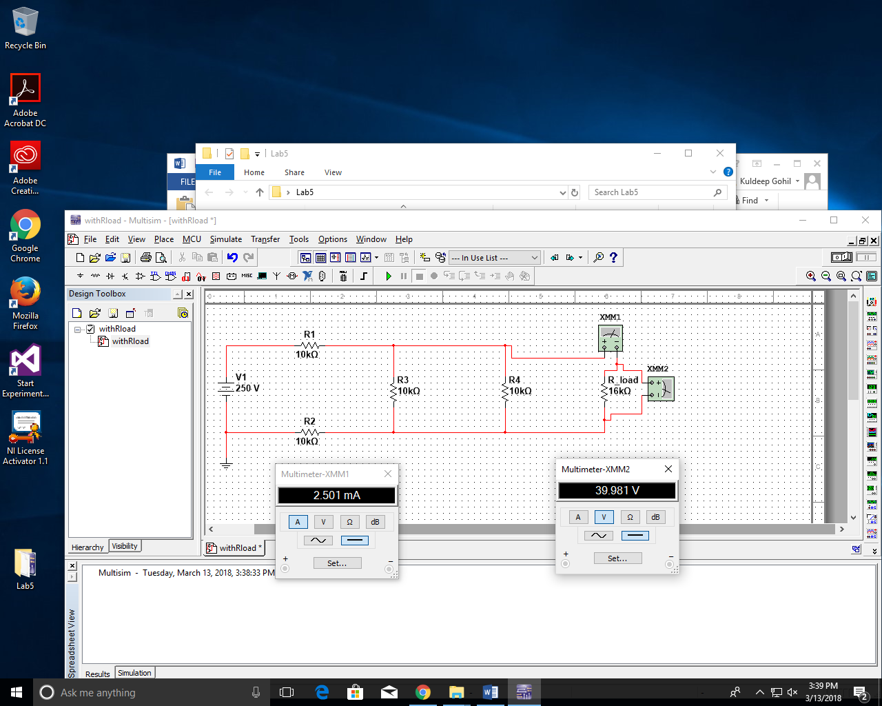

Step 2:

Calculate and draw the Thevenin equivalent circuit for the above circuit without RLoad. You may type the solution and include a schematic from Multisim, or you can do it by hand. Please show all the work for arriving at the Thevenin equivalent circuit.

Step 3:

Using Multisim, simulate the Thevenin equivalent circuit with RLoad and verify that it matches your simulation from Step 1.

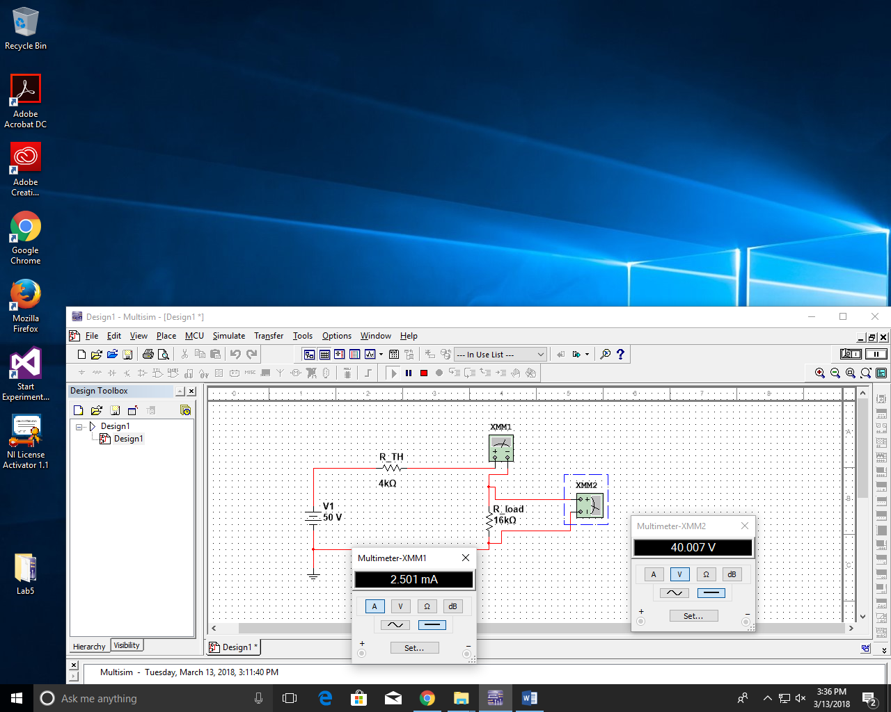

Step 4:

Calculate and draw the Norton equivalent circuit for the above circuit without RLoad. You may type the solution and include a schematic from Multisim, or you can do it by hand. Please show all the work for arriving at the Norton equivalent circuit.

Step 5:

Using Multisim, simulate the Norton equivalent circuit with RLoad and show that it matches your simulation from Step 1.

